**Synopsis**

**1. Title of Project:** Development of a Reasoning and Acting AI Agent with Integrated Real-World Interaction Capabilities

**2. Name of College:** D. Y. Patil Education Society’s, D. Y. Patil Technical Campus Faculty of Engineering & Faculty of Management Talsande Kolhapur.

**3. Name of Department:** Computer Science & Engineering.

**4. Name of Students:**

1. Shweta Vishwas Chavare 3012

2. Prayas Mahadev Ambawade 3003

3. Omkar Bajrang Bhosale 3008

**5. Name of Guide:** Mr.U.A.Patil

**6. Introduction:**

In the era of artificial intelligence, the demand for intelligent systems capable of reasoning, decision-making, and interacting with the real world has grown exponentially. Traditional AI systems often rely on predefined rules or limited datasets, which restrict their ability to adapt to dynamic environments or provide comprehensive solutions. To address these limitations, this project introduces the development of a **Reasoning and Acting AI Agent**, a sophisticated system designed to bridge the gap between reasoning capabilities and real-world interactions.

The proposed AI agent is not just a passive responder but an active participant in solving user queries and performing tasks. It combines the power of a local dataset for intelligent reasoning with the ability to fetch real-time data through API integrations, such as news updates, weather forecasts, and more. Additionally, the agent is equipped with a local database to perform CRUD (Create, Read, Update, Delete) operations, enabling users to store and manage data efficiently. To further enhance its utility, the agent includes features like email communication for seamless interaction and a web search capability to retrieve information from the internet in real-time

**7.Reasoning Significance:**

Reasoning is the cornerstone of intelligent decision-making and problem-solving, enabling systems to process information, draw logical conclusions, and take appropriate actions. In the context of the **Reasoning and Acting AI Agent**, the significance of reasoning can be understood through the following key aspects:

* **Enhanced Decision-Making:**  
  Reasoning allows the AI agent to analyse data, evaluate options, and make informed decisions. By leveraging its local dataset and integrating real-world data through APIs, the agent can provide accurate and contextually relevant responses, ensuring that users receive reliable information tailored to their needs.
* **Contextual Understanding:**  
  Reasoning enables the AI agent to interpret user queries in context, rather than relying on keyword matching or predefined responses. This capability ensures that the agent can handle complex and nuanced questions, making it more effective in real-world applications.
* **Adaptability to Dynamic Environments:**  
  The ability to reason allows the AI agent to adapt to changing circumstances. For example, when fetching real-time data like weather updates or news, the agent can process this information and adjust its responses accordingly. This adaptability is crucial for applications that require up-to-date and accurate insights.
* **Efficient Problem-Solving:**  
  Reasoning empowers the AI agent to break down complex problems into manageable components, identify patterns, and generate solutions. This is particularly useful for tasks such as data management (CRUD operations) or retrieving information from the web, where logical processing is essential for efficient execution.
* **Autonomous Action:**  
  Beyond answering questions, reasoning enables the AI agent to take autonomous actions based on its analysis. For instance, it can send emails, update databases, or perform web searches without explicit user intervention, making it a proactive assistant rather than a reactive tool.

**8. Literature Review:**

The development of a **Reasoning and Acting AI Agent** draws upon a rich body of research and advancements in artificial intelligence, natural language processing, and autonomous systems. Below is a review of key areas relevant to this project:

**1. Reasoning in AI Systems:**

* **Logical Reasoning:**  
  Early AI systems, such as expert systems, relied on rule-based reasoning to solve problems within specific domains. These systems used predefined logical rules to derive conclusions (Russell & Norvig, 2020). While effective in structured environments, they lacked flexibility and scalability.
* **Probabilistic Reasoning:**  
  Modern AI systems, such as Bayesian networks and Markov models, incorporate probabilistic reasoning to handle uncertainty and make decisions under incomplete information (Pearl, 1988). This approach is particularly useful for real-world applications where data is often noisy or incomplete.
* **Machine Learning-Based Reasoning:**  
  Recent advancements in machine learning, particularly deep learning, have enabled AI systems to learn reasoning patterns from large datasets. Models like transformers (Vaswani et al., 2017) have demonstrated remarkable capabilities in tasks requiring logical inference and contextual understanding.

**2. Real-World Data Integration via APIs:**

* **API-Based Data Retrieval:**  
  APIs have become a standard method for integrating real-world data into AI systems. For example, weather APIs like OpenWeatherMap and news APIs like NewsAPI are widely used to fetch real-time information (OpenWeather, 2023; NewsAPI, 2023).
* **Challenges in Data Integration:**

Integrating external data sources requires handling issues such as data  
inconsistency, rate limits, and API downtime. Research in robust data integration techniques (Lenzerini, 2002) provides insights into addressing these challenges.

**3. Database Management in AI Systems:**

* **CRUD Operations in AI:**  
  AI systems often require local databases to store and manage data. Relational databases (e.g., MySQL) and NoSQL databases (e.g., MongoDB) are common used

for this purpose (Elmasri & Navathe, 2016). CRUD operations enable AI systems to interact with stored data dynamically.

* **Integration with AI Models:**  
  Research on database-AI integration (Halevy et al., 2009) highlights the importance of seamless interaction between AI models and databases for efficient data retrieval and manipulation.

**4. Email Communication and Automation:**

* **Automated Email Systems:**  
  Email automation tools, such as SendGrid and SMTP-based systems, are widely used for sending notifications, reminders, and reports (SendGrid, 2023). Integrating email functionality into AI systems enhances their utility in communication tasks.
* **Natural Language Generation for Emails:**  
  Advances in natural language generation (NLG) have enabled AI systems to compose human-like emails (Reiter & Dale, 2000). This capability is particularly useful for personalized communication.

**9.Research Gap:**

|  |  |  |
| --- | --- | --- |
| **Sr. No.** | **Paper Name** | **Research Gap** |
| **1** | Pearl (1988) - *Probabilistic Reasoning in Intelligent Systems* | Addresses uncertainty in reasoning but does not explore integration with APIs or dynamic datasets. |
| **2** | Talmor et al. (2019) - "CommonSenseQA: A Question Answering Challenge" | Targets commonsense reasoning but does not address real-world interaction or email automation |
| **3** | Russell & Norvig (2020) - *Artificial Intelligence: A Modern Approach* | Focuses on theoretical reasoning but lacks practical implementation of real-world data integration. |

**10. Objectives:**

1. To Improve Reasoning Capabilities:
2. To Create a Real-World Data Integration Framework
3. To Improve Database Management Functionality
4. To Create an Automated Communication System
5. To Improve Web Search and Information Retrieval

**11. Block Diagram:**

Flow Chart:

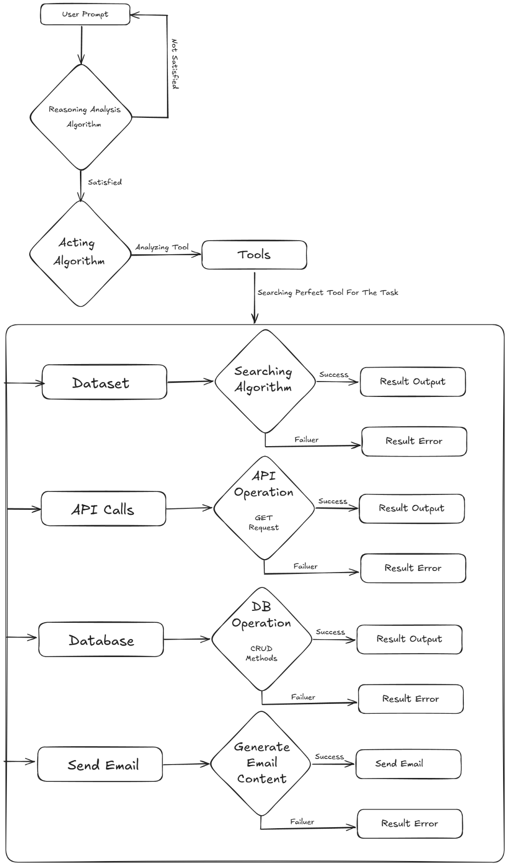

**12. Software Specifications:**

1. NodeJs

2. Llama 3.1 7b AI Model

**13. Work Plan**

|  |  |  |
| --- | --- | --- |
| **Sr.No** | **DATE** | **TASK** |
| 1 |  | Group Creation |
| 2 |  | Topic Discussion |
| 3 |  | Topic Finalization |
| 4 |  | Requirement gathering |
| 5 |  | Synopsis Preparation |
| 6 |  | Synopsis Finalization |
| 7 |  | Synopsis Presentation |
| 8 |  | 50% Work Done |
| 9 |  | Presentation |
| 10 |  | 75% Work Done |

**14. Approximate Expenditure:** 7 Thousand

**13. Conclusion:**

We are going to achieve the development of a **Reasoning and Acting AI Agent** that combines advanced reasoning capabilities with real-world interaction features. By integrating a local dataset for intelligent responses, enabling API-based real-time data fetching, and implementing a robust database for CRUD operations, we aim to create a versatile and dynamic AI system. Additionally, the agent's ability to send emails and perform web searches will further enhance its utility, making it a powerful tool for both personal and professional use.

Through this project, we are going to bridge the gap between reasoning and acting in AI systems, delivering a solution that not only thinks intelligently but also takes meaningful actions based on its reasoning. This achievement will pave the way for more adaptive, efficient, and user-centric AI applications in the future.

**14. Bibliography/ References: -**

1. AWS Blog – What are AI Agents.

2. LangChain Documentations.

3. Task Planning and Tools Usage of LLM-based AI Agent Research Paper

**Place: Talsande Date:**

|  |  |  |
| --- | --- | --- |
| **Roll No.** | **Name of Student** | **Signature of Student** |
| 3012 | Shweta Vishwas Chavare |  |
| 3003 | Prayas Mahadev Ambawade |  |
| 3008 | Omkar Bajrang Bhosale |  |

Mr.U.A.Patil Mr.I.P.Mane Mr.U.A.Patil

**Project Guide DSMP Coordinator HOD**